Shrimp Task Force Meeting
Wednesday, October 20, 2021, 10:00am
LDWF Headquarters
2000 Quail Dr.
Baton Rouge, LA 70898

I. Pledge of Allegiance
II. Roll Call
Voting Members Present:
Rodney Olander
Acy Cooper
Ronald Anderson
Kristen Baumer
Alan Gibson
Andrew Blanchard
Chalin Delaune
Jeff Drury

Voting Members Absent:
Lance Nacio
Philip Tran

Non-Voting Members Present:
Peyton Cagle
Bryan Marie
Jack Isaacs

Non-Voting Members Absent:
Meg Bankston
Gene Cavalier
Justin Gremillion

III. Rodney Olander motioned to approve the August 4, 2021 meeting minutes, 2nd by Acy Cooper. Motion carries.

IV. Rodney Olander motioned to amend the agenda by adding item E. To Discuss Shrimp Containers in China and item F. To Discuss Shrimp Prices, 2nd by Alan Gibson. Motion carries.

Acy Cooper motioned to approve the agenda as amended, 2nd by Kristen Baumer. Motion carries.

V. Financial Report
Remaining Fund Balance- $676,737
Remaining Budget Balance- $70,331

Acy Cooper motioned to approve the financial report, 2nd by Kristen Baumer. Motion carries.

VI. The task force received an updated Federal Shrimp Permit Report

VII. New Business:
- The task force discussed the distribution process for CARES Act funding
Rodney Olander stated that a lot of guys qualified the first time and not the second time, because the whole year of 2020 was included, so instead of helping it’s hurting quite a few fishermen; why wasn’t it either 3-4 month time period or a full year losses and why isn’t helping as many fishermen as possible
Richard Williams, LDWF, after a few meetings it was decided to go with the full year, one of the main reasons for this was due to the time it takes to change the website. If a change was made, that would push back the start date of the program and we were trying to get money to the fishermen as soon as possible, the other reason was any change to the plan has to be approved by NOAA, also it was only the difference of 250 applications
Acy Cooper stated that rewarding the guys who stayed at home and punishing the guys who went to work, not fair to the ones who got it the first round

Rodney Olander stated that the task force is set up to make recommendations to the agency and they don’t take the recommendations

Richard Williams stated that some changes were suggested and NOAA did not take them into consideration

Alan Gibson stated that the governor’s office representative supposed to be here, feel like the industry is not being heard by the Governor’s office, the industry needs to be represented

Andrew Blanchard stated that as much board member participation as we can get the better, LDWF does the best they can

Richard Williams stated that LDWF has to submit the list to NOAA, NOAA then has to approve it and then the funding can be distributed, and will be all one payment this time, trip tickets were not used to determine the 35% loss, taxes were

During CARES Act I there was only a few months’ worth of data to go off of, for CARES Act II there was a whole year worth of data available, other states were using the whole year and it was suggested by NOAA that the whole year be used
- Peyton Cagle provided an update on fisheries disaster assistance for Hurricane Ida
A federal fisheries disaster has not yet been declared, Congress passed an appropriations bill to include up to $200M to NOAA for fisheries disasters, which is basically a fisheries disaster bank account, this money is not just for Hurricane Ida or for any specific event or for just one state. At this time a true disaster from the Secretary of Commerce has not been declared. A fisheries disaster is usually declared with an economic impact statement and other data/ feedback from LDWF, currently in the data gathering process now, instead of doing what was done with the 2019 disaster looking at going back to what was done for Gustave, which is a Sea Grant model approach, possibly qualifying for two disasters as we are looking at storms from last year (Laura, Delta, Zeta) and Ida this year , very similar to what was done with the industry after Katrina, in the process of collecting more data to use that model approach
- Alan Gibson led discussion on the LA Sea Grant purpose and services to the shrimp industry
Alan Gibson stated that there was a lot of concern in Dulac about what happened with the loaning of generators
Rex Caffey stated that in listening to last week’s LDWF Commission meeting he knows there is a lot of frustration. In the wake of di been around 50 years, when Ida hit asked Tom Hymel and Rusty Gaudet come in and do what they could to help the local agents and to do some initial assessment. About that time this new group BEOC (Business Emergency Operation Center) had been set up at ULL. The Governor and LDWF asked if Sea Grant could help them identify where they can put three locations to provide free ice to the community. Wish they had more capacity. We can always do better and are looking for ways to do better. When someone buys a permit/ license they have an option to provide a phone number and contact information, need contact information to be able to reach everyone in the industry when an incident like this happens. Hopes that the industry will help build the contact list. The Louisiana Fishing Recovery Community Coalition, is an industry led lobbying effort to get some money right now. Sea Grant is running damage assessments with LDWF to aid the coalition in this effort and would like the industry’s help with filling out surveys to assist in assessing damages
Acy Cooper we should have a program in place we went through this before we know the issues, why hasn’t something been put together already? For us not to have a plan or protocol in place is our issue, we need a recovery plan
Thomas Hymel stated that there needed to be a better way but at the time there was not; there is a group called BEOC and they are the group that responds to the Governor and business emergency. They contacted me and said the Governor has given his cabinet the task of bringing some relief to the seafood industry. This same group was the same ones distributing gasoline and making sure that was out there and now they were shifting from gasoline to how they could help the seafood industry. Provided feedback to the BEOC and they created a list of priorities of where generators could be placed for the community benefit. There was no list or disaster management plan this was built on the fly and it was an absolute miracle anything happened at all. A plan needs to be put in place and Sea Grant is here to help make this happen.
Alan Gibson stated that the concern that blew up with me is every time something happens in Dulac it’s the same group of people who receive help, everyone in the industry needs to be treated equally, did not hear anything for over a week; a plan does need to be set up, this needs to be addressed and pretty quickly
- Secretary Jack Montoucet stated that during an emergency there is no time to call people and have a vote on what is to be done, there is no perfect plan; it’s time for action you have to move forward, had to act fast, will come up with a disaster plan but even with a plan things change in a moment’s notice; talked with ULL about putting together an identification map with every location on the map, which would provide a good view of what the industry looks like, setting up a priority list beforehand will not work as you do not know what a hurricane will do/ where it will hit; need a meeting with Sea Grant and ULL to begin the process of starting to draft a plan
Acy Cooper asked that the industry be involved in putting together the disaster recovery plan
- The task force discussed Senate Resolution 105, which provides relative to taking shrimp in Lake Pontchartrain
The board needs to meet with the Crab Task Force to come up with recommendations on what can be done in that area to make it work between the two user groups; need something by February 4, 2022
Committee to represent the shrimp task force on this item, recommended Chalin Delaune, Acy Cooper, and Andrew Blanchard serve on the committee as task force representatives
Cole Garrett stated that setting up a meeting prior with Senator Lambert would help
- Jack Isaacs provided a presentation on European shrimp imports
Imports into the E.U.-28: 2020
Pounds | Value
1.2 Billion | $4.0 Billion

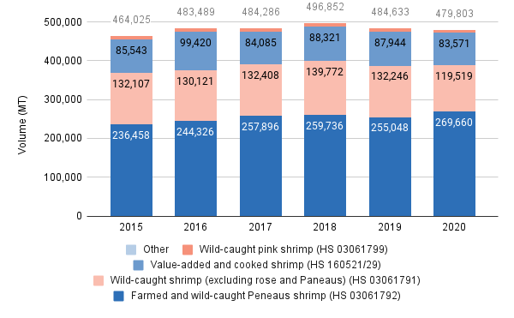
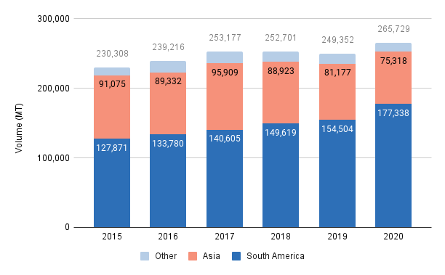
- The task force discussed shipping containers in China and Shrimp prices
China has 1000-1200 shipping containers from India full of shrimp infected with Covid-19, concern about these shrimp coming into the US and at prices below market value, dropping the shrimp prices even lower
There needs to be some government agencies to let them know about this issue all commodities dropping why? Look at inventory costs this year vs last year is about 50% higher than last year. Trying to sell, need an equivalency standard here in America
Jack Isaacs stated that the value that the manufacturer/producer gets is based upon the difference between the retail market and the final market and the transportation costs, so if the transportation costs are going up it could be making a bigger gap between those things and pushing the price down
Kristen Baumer stated that the best way to promote domestic shrimp is to incentivizing retailers and food service companies to want to promote it, because we are asking them to promote a limited resource that ultimately causes their price to go up, so anytime we have promotion board money if we can incentivize a retailer to run a promo and tell their customers how good our shrimp is as a state we should be doing that
Ronald Anderson stated that for 20 years that imports need to be demoted, in order for local product to be promoted imports needs to be demoted; need to go up to D.C. and try to lobby to appeal the Byrd Amendment
- The task force considered funding for STF travel to Washington, D.C.
Acy Cooper motioned to spend up to $15,000 to pay for board member travel, 2nd by Rodney Olander. Motion carries.
VIII. Public Comment
Acy Cooper stated that currently working on complete waiver for the State of Louisiana, LA would be an exclusion zone, goes into effect in February 2022 trying to get this exemption before then
Peyton Cagle stated that 1. at the last meeting Audubon Gulf came to discuss external review, which was a part of the FIP, did two different draft proposals for pricing, one was voted on over the other, where we are now- Audubon Gulf has sent a draft of the agreement to send out to the STF board members for review, please review it and comment on it to come back to the next meeting with one draft that can be provided back to Audubon; 2. TED exemptions for trawlers have been submitted, awaiting final approval, trying to get a trawl exemption from the Atchafalaya all the way east; 3. TED reimbursement for skimmers, did this for almost a full year, if you attend an online webinar meeting you could recoup up to 50-60% of your skimmer TED cost. There is another webinar online on October 26th, you can sign up on the LDWF website, the program will end at the end of January 2022. As of right now this is for 40ft vessels and up
Acy Cooper asked about how removing TEDs will impact sustainability certification?
IX. Next meeting was set for Wednesday, December 8, 2021 10am at the Lakefront airport at the Terrebonne Port Commission in Houma
X. Rodney Olander motioned to adjourn, 2nd by Acy Cooper. Motion carries.

